Annexe - ML Experiment Configuration and Execution

1. Introduction: A Framework for Reproducible ML Experiments
This annexe outlines the configuration and execution framework for the flight delay prediction project. The strategic importance of this system lies in establishing a robust and standardized process for conducting machine learning experiments. By separating experiment configuration from the core application logic, this framework ensures that every experiment is reproducible, scalable, and easily manageable, allowing teams to define, modify, and run complex data pipelines and model training routines without altering the underlying source code.
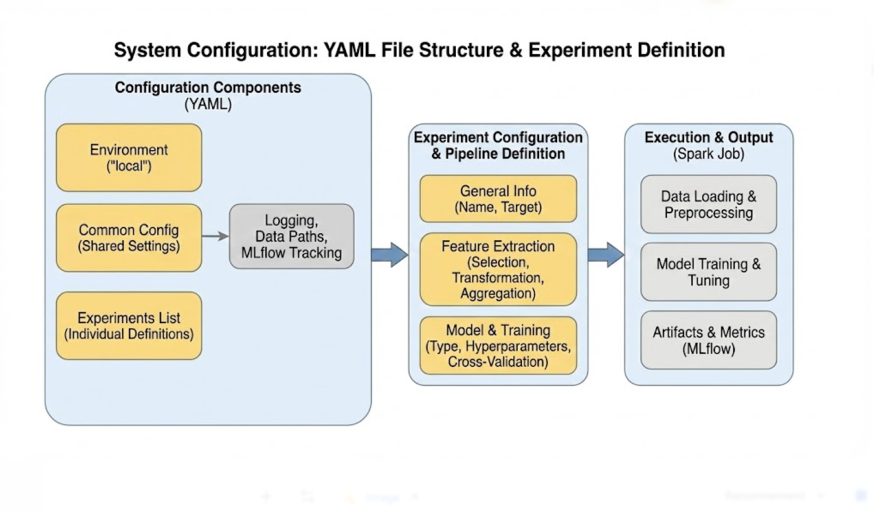

The system is built upon two core components. The first is a central YAML configuration file (config.yml), which serves as the declarative blueprint for an experiment, defining everything from data sources and feature engineering steps to model hyperparameters. The second component is a set of shell scripts (local-submit.sh and spark-submit.sh) that act as the operational engine, responsible for launching and managing the Spark execution environment based on the specified configuration.
This document will now proceed with a detailed examination of the configuration system, followed by the execution workflow that brings these declarative experiments to life.

2. The Configuration System: config.yml
The YAML configuration file is the central hub for defining all aspects of a data processing and modeling experiment. It provides a human-readable, declarative interface to control the entire ML pipeline, from initial data loading to model training and evaluation. This section deconstructs the file's structure and key parameters, demonstrating how users can define complex pipelines in a simple, organized manner.
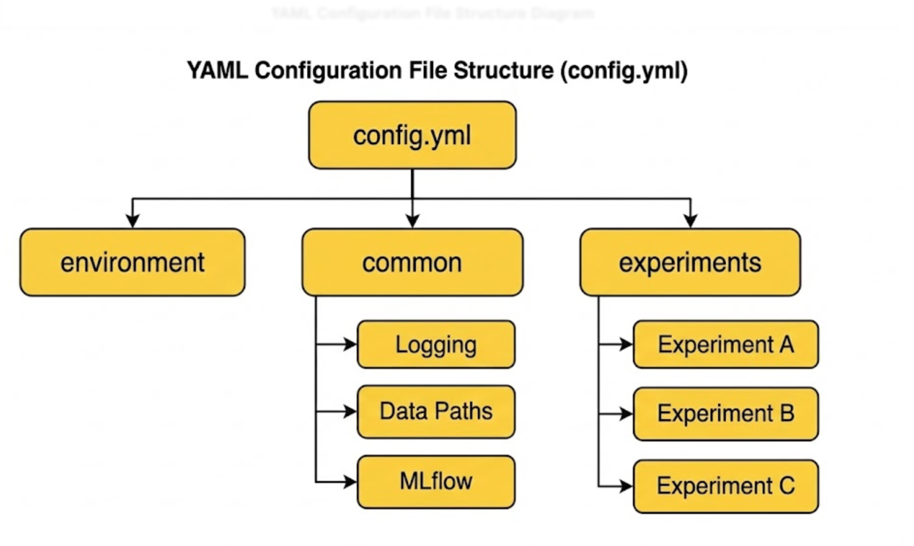

2.2. Analyze the Top-Level Structure
The configuration file is organized into three primary top-level keys, each serving a distinct purpose:
- environment: Specifies the execution environment (e.g., "local"), allowing for environment-specific settings.
- common: Contains global parameters and settings that are shared across all experiments defined within the file.
- experiments: Holds a list of individual experiment definitions, each with its own specific feature extraction and modeling configuration.

2.3. Deconstruct the common Configuration Block
The common block centralizes parameters that apply globally, ensuring consistency and reducing redundancy across different experiments. These settings control fundamental aspects like data paths, logging, and integration with tracking services.
Parameter | Description
seed | An integer used to initialize random number generators, ensuring reproducibility of results.
log | A boolean flag (true/false) to enable or disable all application logging.
logLevel | Sets the minimum logging level to display (e.g., info, debug, warn).
loadDataFromCSV | A boolean flag; if true, data is loaded from CSV files, otherwise from raw Parquet files.
storeIntoParquet | A boolean flag; if true, the initially loaded data is saved in the efficient Parquet format.
data | A nested object containing the base path and relative paths for input datasets like flights and weather.
output | A nested object specifying the base path where output artifacts should be stored.
mlflow | A nested object to configure MLflow integration, including an enabled flag and the trackingUri.

2.4. Deconstruct the experiments Configuration Block
The experiments key contains a list of one or more experiment definitions. This structure allows multiple experimental variations—such as different models, feature sets, or hyperparameters—to be managed within a single configuration file. For this analysis, we will focus on the example experiment named "Experience-md-rf-local-D2-60-7-7".
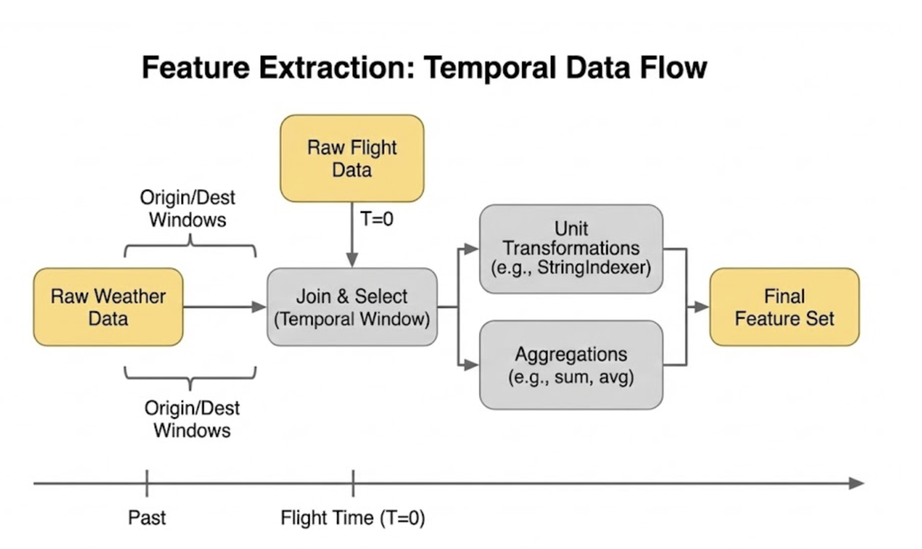

Each experiment begins with several descriptive keys:
- name: A unique identifier for the experiment (e.g., "Experience-md-rf-local-D2-60-7-7").
- description: A human-readable summary of the experiment's goal (e.g., "Baseline Random Forest with hyperparameters tuning").
- enabled: A boolean flag that determines whether this specific experiment will be run when the application is executed.
- target: The name of the target column for the prediction task (e.g., "is_delayed").

2.5. Deep Dive: featureExtraction Configuration
This section dictates all data preprocessing and feature engineering steps, defining how raw data is transformed into a feature set ready for model training.
Key parameters at the top level of the featureExtraction block include:
Parameter | Description
type | The type of feature extraction process to apply (e.g., "feature_selection").
dxCol | Specifies the column defining the delay event (e.g., "D2_60").
delayThresholdMin | The threshold in minutes to classify a flight as delayed (e.g., 60).
weatherOriginDepthHours | The time window in hours to look back for weather data at the origin airport.
weatherDestinationDepthHours | The time window in hours to look back for weather data at the destination airport.
handleInvalid | The strategy for handling invalid or null values in categorical features (e.g., "keep").
storeJoinData | A boolean flag to control whether the intermediate joined dataset is saved to disk.
storeExplodeJoinData | A boolean flag to control whether the intermediate exploded-join dataset is saved.
maxCategoricalCardinality | The maximum number of unique values a categorical feature can have before being handled.

flightSelectedFeatures
This block lists the specific features to be selected from the flight dataset. For each feature, a transformation is specified.
- CRS_DEP_TIME: transformation: "None"
- OP_CARRIER_AIRLINE_ID: transformation: "StringIndexer"
- ORIGIN_AIRPORT_ID: transformation: "StringIndexer"
- DEST_AIRPORT_ID: transformation: "StringIndexer"
- CRS_ELAPSED_TIME: transformation: "None"
- feature_departure_hour_rounded_sin: transformation: "None"
- feature_departure_hour_rounded_cos: transformation: "None"
- feature_flight_week_of_year_sin: transformation: "None"
- feature_flight_week_of_year_cos: transformation: "None"
- feature_departure_time_period: transformation: "StringIndexer"
- feature_arrival_time_period: transformation: "StringIndexer"

weatherSelectedFeatures
This block specifies the features to be selected from the weather dataset, along with their respective transformations.
- feature_weather_type: transformation: "StringIndexer"
- feature_weather_intensity: transformation: "StringIndexer"
- feature_flight_category_ordinal: transformation: "None"
- feature_visibility_category: transformation: "StringIndexer"
- feature_icing_risk_level: transformation: "None"
- feature_icing_risk_flag: transformation: "None"
- feature_is_pressure_dropping_fast: transformation: "None"
- HourlyPrecip: transformation: "None"
- RelativeHumidity: transformation: "None"
- press_change_abs: transformation: "None"
- feature_temp_dewpoint_spread: transformation: "None"
- Temp_Delta_1hr: transformation: "None"
- Visibility_Delta_1hr: transformation: "None"
- Humidity_Delta_1hr: transformation: "None"
- WindSpeed_Delta_1hr: transformation: "None"

aggregatedSelectedFeatures
This block defines features that are created by aggregating weather data over the specified time window. Each entry includes the feature name, an aggregation function, and a final transformation.
- HourlyPrecip: aggregation: "sum", transformation: "None"
- RelativeHumidity: aggregation: "avg", transformation: "None"
- press_change_abs: aggregation: "max", transformation: "None"
- feature_temp_dewpoint_spread: aggregation: "min", transformation: "None"

2.6. Deep Dive: model Configuration
The model block defines the machine learning model to be trained, its specific hyperparameters, and the training procedure.
- modelType: Specifies the algorithm to use, in this case, "randomforest".
- hyperparameters: A nested object containing the parameters for the chosen model.
  - numTrees: The number of trees in the forest.
  - maxDepth: The maximum depth of each tree.
  - maxBins: The maximum number of bins used for discretizing continuous features.
  - minInstancesPerNode: The minimum number of instances each node must have.
  - subsamplingRate: The fraction of the training data to use for learning each tree.
  - featureSubsetStrategy: The number of features to consider when looking for the best split.
  - impurity: The criterion used for information gain calculation (e.g., "gini").
- train: A nested object that controls the training and evaluation process.
  - fast: A boolean flag; when true, it skips the computationally expensive cross-validation step.
  - trainRatio: The proportion of the dataset to allocate for training (e.g., 0.75).
  - crossValidation: Contains settings for cross-validation.
    - numFolds: The number of folds to use in cross-validation.
    - gridSearch: An object with an enabled flag and the evaluationMetric (e.g., "f1") used to select the best model from the hyperparameter grid.
The declarative nature of the YAML file provides a clear and version-controllable definition of each experiment, which is then actioned by the operational scripts that bring it to life.

3. The Execution Workflow: From Local Submission to Spark Job
This section details the operational scripts that parse the experiment configuration and launch it as a Spark job. The workflow is orchestrated by two scripts: local-submit.sh, which serves as the user-facing wrapper for local execution, and spark-submit.sh, the core engine that configures and launches the Spark application. This two-script design provides a powerful abstraction layer, allowing users to specify high-level resource needs (e.g., '2 workers') while the system automatically translates this into a finely-tuned Spark environment with specific memory, core, and parallelism settings.
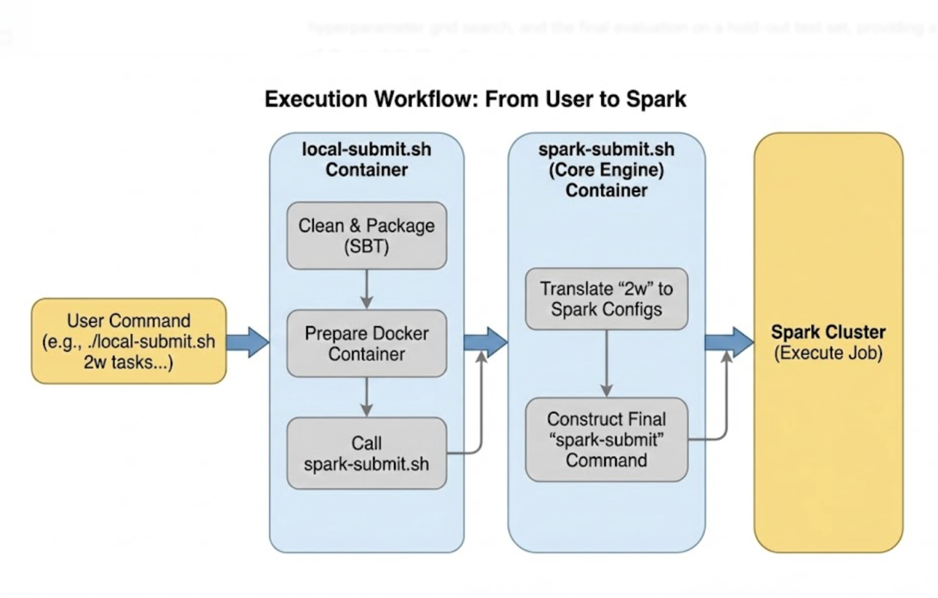

3.2. User Entry Point: local-submit.sh
The local-submit.sh script is the primary user entry point for initiating an experiment locally. It simplifies the execution process by abstracting away the complexities of building the project and configuring the Spark submission command.
At the top of the script, three main environment variables are set to control the job:
- WORKERS: Specifies the number of workers to simulate for the Spark cluster (e.g., 1w, 2w, 4w).
- TASKS: A comma-separated list of tasks to execute (e.g., "data-pipeline,feature-extraction,train").
- EXPERIENCE: Defines the name of the experiment to run. Note: This variable must be manually updated to match the name of the target experiment in the configuration file.
The script includes user-friendly conditional logic for the $WORKERS variable. If the variable is not set or invalid, it provides helpful echo statements with examples of valid usage and worker configurations, guiding the user on how to run the script correctly.
The script executes the following sequence of commands:
- sbt clean package: Cleans previous builds and packages the application into a JAR file.
- echo "--> Spark job built.": Prints a status message to the console.
- docker exec -it spark-submit chmod +x /scripts/spark-submit.sh: Ensures the core submission script is executable within the container.
- docker exec -it spark-submit /scripts/spark-submit.sh "$WORKERS" "$TASKS" "$EXPERIENCE": Invokes the core spark-submit.sh script, passing the worker, task, and experiment settings as arguments.
This script effectively orchestrates the entire build and submission process, providing a simple and consistent interface for the user.

3.3. Core Engine: spark-submit.sh
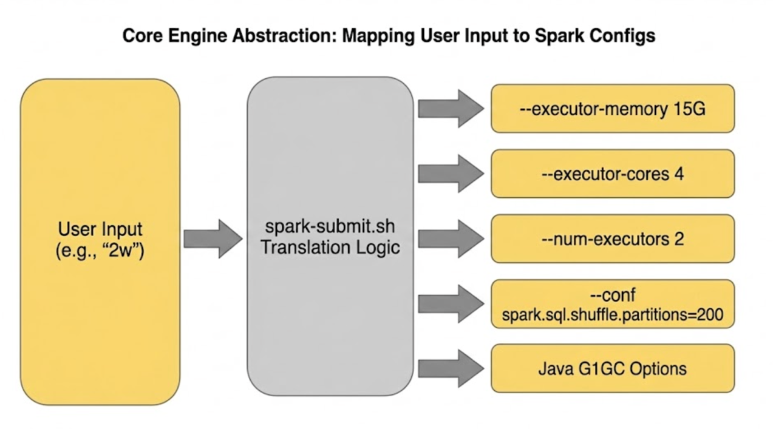

The spark-submit.sh script is the powerful backend responsible for translating the simple worker count provided by the user into a finely-tuned Spark environment. It dynamically sets resource allocation parameters based on the $WORKERS variable.
The script's conditional logic adjusts key Spark parameters to scale the job's resources appropriately. The configurations are summarized below:
Worker Setting | Executor Memory | Executor Cores | Num Executors | Shuffle Partitions
1w | 8G | 4 | 1 | 160
2w | 15G | 4 | 2 | 200
4w | 15G | 3 | 4 | 240
The core of the script is the final spark-submit command, which is meticulously constructed with numerous configuration flags organized into logical groups:
- # MEMORY CONFIGURATION: Sets the memory and cores for the driver and executors (--driver-memory, --executor-memory, --num-executors, etc.).
- # MEMORY SPARK TUNING: Fine-tunes Spark's internal memory management (--conf spark.driver.maxResultSize, --conf spark.memory.fraction).
- # PARALLELISM SQL: Controls the level of parallelism for Spark SQL operations (--conf spark.sql.shuffle.partitions, --conf spark.default.parallelism).
- # SERIALIZATION & NETWORK: Configures data serialization and network settings. The spark.serializer is set to KryoSerializer, a common performance optimization over the default Java serializer for complex data structures often found in ML pipelines.
- # BROADCAST & COMPRESSION: Manages settings for broadcast joins and data compression (--conf spark.broadcast.compress, --conf spark.sql.autoBroadcastJoinThreshold).
- # GARBAGE COLLECTION (RF / GBT): Provides specific Java garbage collection tuning via spark.executor.extraJavaOptions. These settings tune the G1GC garbage collector, which is crucial for preventing long GC pauses in memory-intensive algorithms like Random Forest (RF) and Gradient-Boosted Trees (GBT).
- # EVENT LOGGING: Enables and configures Spark's event logging for monitoring and debugging (--conf spark.eventLog.enabled).
Finally, the script passes the $EXPERIENCE and $TASKS variables as command-line arguments to the main application JAR (Emlaad-Flight-Data-Analysis.jar), instructing it which experiment to run and which stages of the pipeline to execute.
Together, these two scripts provide a powerful abstraction layer, translating a simple user command into a robust, optimized Spark job and enabling a user-friendly yet highly configurable execution workflow.

4. Practical Usage Guide: Running an Experiment
This section provides a practical, step-by-step guide to running an experiment, synthesizing the concepts from the configuration and execution sections into a clear workflow. The goal is to walk a user through the process of configuring and launching a specific experiment.

Step 1: Configure the Experiment
Begin by opening the my-experiment-config.yml file. This is where you can define or modify any aspect of your experiment. For example, you can alter a model hyperparameter in the model.hyperparameters block by changing the value for maxDepth or modify a feature transformation in the featureExtraction.flightSelectedFeatures list.

Step 2: Execute the Local Submission Script
Once the configuration is set, you can launch the experiment from your terminal using the local-submit.sh script.
With the script, you can execute it from the command line, providing the number of workers and the list of tasks as arguments.
# Example to run the 'data-pipeline' and 'train' tasks with 2 workers:
./local-submit.sh 2w data-pipeline,train my-experiment

# Example to run the full pipeline with 4 workers:
./local-submit.sh 4w data-pipeline,feature-extraction,train my-experiment
Executing the first command sets $WORKERS to 2w and $TASKS to data-pipeline,train. The script then initiates the SBT build process and triggers the Spark job inside the Docker container, using the EXPERIENCE name you configured within the script.

Step 3: Monitor the Output
After execution, monitor the console for output from SBT, Spark, and the application's internal logging system. This provides real-time feedback on the job's progress. If MLflow is enabled in the common configuration, the experiment's parameters, metrics, and artifacts will be automatically tracked and visible in the MLflow UI at the specified trackingUri.
By combining declarative configuration with a streamlined execution workflow, this system provides a robust framework for advanced machine learning development. The clear separation of concerns promotes reproducibility, while the scalable execution engine supports both rapid local prototyping and larger-scale jobs, establishing a solid foundation for reliable and efficient experimentation.

